**Sokoban Sweden**

created by Ola Wiebe, Malena Bengtsson and Victor Törnbom 2019

Sokoban Sweden is a great Swedish Sokoban game. The goal is to get all the stones onto the flags without losing or putting the stones in an impossible position. It has 4 different levels with varying difficulty. It takes great intelligence to complete them all. Your number of moves is counted as you play.

You have two different powerups which can help you on the way. One is that you can break a wall of your choice and the other one is that you can push two stones at once.

It is made with complex HTML, CSS, Javascript and Vue code. Hope you enjoy the game!

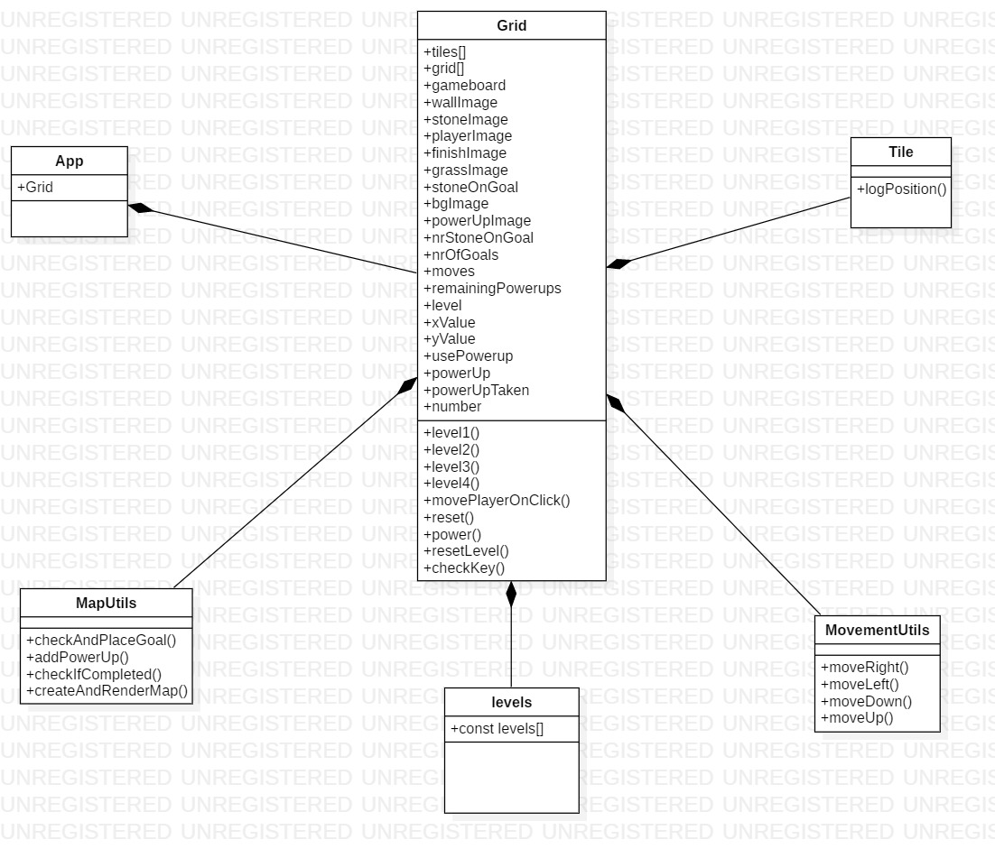STARUML Diagram